Name____________________________________________________________________Date_____________Per_________________

**Topic: Linear Functions**

**Bell Work**

**1) Solve for y: 2*x* + 3*y* = 6 (hint: get y by itself)**

**2) Graph the following set of ordered pairs: (1,-5), (-1, -2), (3,1), (5,4)**

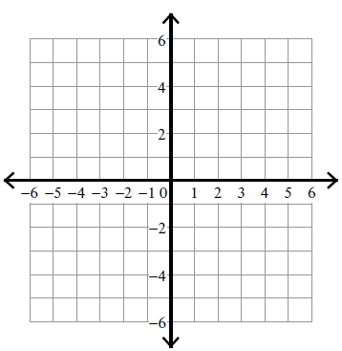

**3) Using y = -2*x* + 1, find the values of *y* when *x* = {-3, 0, 2}**